Mobile Application Lab Exercise 6-A
Now let’s to add a Fragment to a Mobile App and passing values between two fragments by following the steps below;

- Open Android Studio and create a new Mobile App called MyFragment, and make sure you are selecting JAVA programming language.
- Wait until the Mobile App completed its settings
- Open the file activity_main.xml in design mode, and you will see a single TextView component with Hello World! Message. Delete the TextView component.
- Open the activity_main.xml, and delete its content. Add the following code to it
<?xml version="1.0" encoding="utf-8"?>
<LinearLayout xmlns:android="http://schemas.android.com/apk/res/android"
android:layout_width="match_parent"
android:layout_height="match_parent"
android:orientation="vertical">

<WebView
android:id="@+id/container_id"
android:layout_width="match_parent"
android:layout_height="484dp"
android:layout_marginTop="70sp"/>

<androidx.fragment.app.FragmentContainerView
android:id="@+id/fragment_container_two"
android:layout_width="match_parent"
android:layout_height="254dp"
android:layout_marginTop="30sp"
android:layout_below="@+id/container_id"
android:layout_weight="1" />

</LinearLayout>

- Add a new xml file called fragmentlist.xml under res -> layout folder. Open the file and add the following codes
<?xml version="1.0" encoding="utf-8"?>
<LinearLayout xmlns:android="http://schemas.android.com/apk/res/android"
android:layout_width="match_parent"
android:layout_height="match_parent"
android:orientation="vertical">

<ListView
android:id="@+id/myListView"
android:layout_width="match_parent"
android:layout_height="match_parent"
/>

</LinearLayout>

- Add another xml file called fragment_web_view.xml under res -> layout folder. Open the file and add the following codes
<?xml version="1.0" encoding="utf-8"?>
<LinearLayout xmlns:android="http://schemas.android.com/apk/res/android"
xmlns:tools="http://schemas.android.com/tools"
android:layout_width="match_parent"
android:layout_height="match_parent"
tools:context=".WebViewFragment">

<WebView
android:id="@+id/WebViewId"
android:layout_width="match_parent"
android:layout_height="match_parent"

/>

</LinearLayout>

- Open the AndroidManifest.xml, and add the following line
<uses-permission android:name="android.permission.INTERNET"/>
Before <application tag. Also, add the following line
android:usesCleartextTraffic="true"
inside the <application tag

- Open MainActivity.java file, and import the following packages

import android.os.Bundle;
import androidx.fragment.app.Fragment;
import androidx.activity.EdgeToEdge;
import androidx.appcompat.app.AppCompatActivity;
import androidx.core.graphics.Insets;
import androidx.core.view.ViewCompat;
import androidx.core.view.WindowInsetsCompat;
import androidx.fragment.app.FragmentManager;
import androidx.fragment.app.FragmentTransaction;

- Add the following codes after
return insets;
});

if (savedInstanceState == null) {
// Get the FragmentManager and begin a transaction
FragmentManager fragmentManager = getSupportFragmentManager();
FragmentTransaction transaction = fragmentManager.beginTransaction();
// Add the first fragment
transaction.add(R.id.fragment_container_two, new MyFragment());
// Commit the transaction
transaction.commit();
}

- Add a new java class called MyFragment, and then edit the file and delete the class definition. Add the following codes to it
import android.os.Bundle;
import android.view.LayoutInflater;
import android.view.View;
import android.view.ViewGroup;
import android.widget.AdapterView;
import android.widget.ArrayAdapter;
import android.widget.ListView;
import android.widget.Toast;
import androidx.annotation.NonNull;
import androidx.annotation.Nullable;
import androidx.fragment.app.Fragment;
import java.util.Collection;
public class MyFragment extends Fragment {
ListView listView;
@Override
public View onCreateView(LayoutInflater inflater, ViewGroup container, Bundle savedInstanceState) {
View view = inflater.inflate(R.layout.fragment_list, container, false);
listView = view.findViewById(R.id.myListView); // Use rootView
String[] data = new String[]{"Google", "Bradford University", "Yahoo"};
ArrayAdapter<String> adapter = new ArrayAdapter<>(requireActivity(), android.R.layout.simple_list_item_1, data);
listView.setAdapter(adapter);
listView.setOnItemClickListener(new AdapterView.OnItemClickListener() {
@Override
public void onItemClick(AdapterView<?> parent, View view, int position, long id) {
// Your click handling logic here
Toast.makeText(getContext(), " Item position is "+ parent.getItemAtPosition(position).toString(),Toast.LENGTH_SHORT).show();
Bundle mBundle= new Bundle();
mBundle.putString("myURL",parent.getItemAtPosition(position).toString());
final WebViewFragment mFragment = new WebViewFragment();
mFragment.setArguments(mBundle);
requireActivity().getSupportFragmentManager().beginTransaction().replace(R.id.container_id,mFragment).commit();
}
});
return view;
}
}

- Add a new java class called WebViewFragment, and then edit the file and delete the class definition. Add the following codes to it
import android.annotation.SuppressLint;
import android.os.Bundle;
import androidx.fragment.app.Fragment;
import androidx.fragment.app.FragmentResultListener;
import android.view.LayoutInflater;
import android.view.View;
import android.view.ViewGroup;
import android.webkit.WebView;
import android.webkit.WebViewClient;
import android.widget.Toast;
import java.util.Objects;
public class WebViewFragment extends Fragment {
String urls;
@SuppressLint("SetJavaScriptEnabled")
@Override
public View onCreateView(LayoutInflater inflater, ViewGroup container,
Bundle savedInstanceState) {
// Inflate the layout for this fragment
View view= inflater.inflate(R.layout.fragment_web_view, container, false);
Bundle bundle = getArguments();
urls= bundle.getString("myURL");
if (Objects.equals(urls, "Google")) {
urls ="https://www.google.com";
} else if (Objects.equals(urls, "Bradford University")){
urls ="https://www.bradford.ac.uk/external";
} else if (Objects.equals(urls, "Yahoo")){
urls="https://www.yahoo.com";
}
Toast.makeText(getActivity(), " Item position is "+ urls,Toast.LENGTH_SHORT).show();
WebView webView = view.findViewById(R.id.WebViewId);
webView.getSettings().setJavaScriptEnabled(true);
webView.setWebViewClient(new WebViewClient());
webView.loadUrl(urls);
return view;
}
}

Now Run the Application and you should see the following screen.
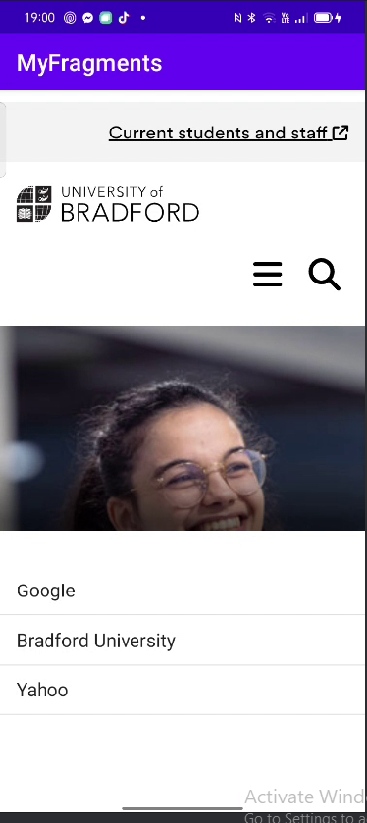

Mobile Application Lab Exercise 6-B
Now let’s to add a Fragment to a Mobile App and passing values between two fragments by following the previous steps and to produce the following Mobile App.
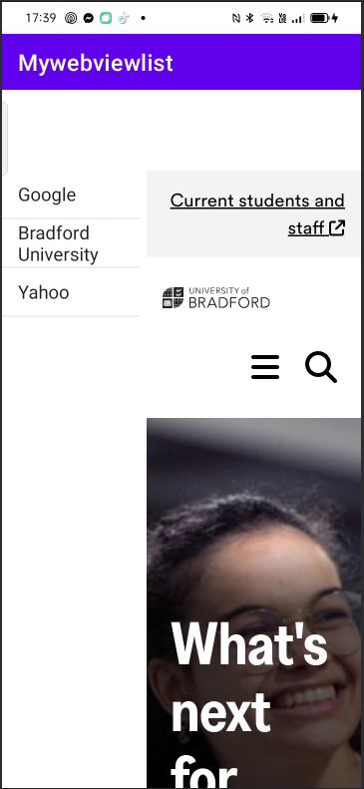

Mobile Application Lab Exercise 6-c

- You need to create your own fragment layout file called listitems.xml in \res\layout path to display the fragment in the main layout for that right-click on your layout folder à Go to New -> select Layout resource file and give name as listitems.xml.
- Open the listitems.xml file and add the following codes
<?xml version="1.0" encoding="utf-8"?>
<LinearLayout xmlns:android="http://schemas.android.com/apk/res/android"
android:orientation="vertical" android:layout_width="match_parent"
android:layout_height="match_parent">
<ListView
android:layout_width="match_parent"
android:layout_height="wrap_content"
android:id="@android:id/list" />
</LinearLayout>

- Same way creates another file details.xml, open it and add the following code
<?xml version="1.0" encoding="utf-8"?>
<LinearLayout xmlns:android="http://schemas.android.com/apk/res/android"
android:orientation="vertical" android:layout_width="match_parent"
android:layout_height="match_parent"
android:background="#0079D6">
<TextView
android:layout_width="wrap_content"
android:layout_height="wrap_content"
android:textColor="#ffffff"
android:layout_marginTop="200px"
android:layout_marginLeft="200px"
android:id="@+id/Name"/>
</LinearLayout>

- Now we need to create our own custom fragment class file (DetailsFragment.java) after the package statement

import android.app.Fragment;
import android.os.Bundle;
import android.view.LayoutInflater;
import android.view.View;
import android.view.ViewGroup;
import android.widget.TextView;
public class DetailsFragment extends Fragment {
TextView name,location;
@Override
public View onCreateView(LayoutInflater inflater, ViewGroup container, Bundle savedInstanceState) {
View view = inflater.inflate(R.layout.details_info, container, false);
name = (TextView)view.findViewById(R.id.Name);
location = (TextView)view.findViewById(R.id.Location);
return view;
}
public void change(String uname, int mycolor){
name.setTextColor(mycolor);
name.setText(uname);
}

- Same way creates another file ListItemsFragment.java,, open it and add the following the codes after the package statement

import android.app.ListFragment;
import android.os.Bundle;
import android.view.LayoutInflater;
import android.view.View;
import android.view.ViewGroup;
import android.widget.ArrayAdapter;
import android.widget.ListView;
public class ListItemesFragment extends ListFragment {
String[] users = new String[] { "Yellow","Blue","Black","Red","White" };
@Override
public View onCreateView(LayoutInflater inflater, ViewGroup container, Bundle savedInstanceState) {
View view =inflater.inflate(R.layout.listitems_info, container, false);
ArrayAdapter<String> adapter = new ArrayAdapter<String>(getActivity(), android.R.layout.simple_list_item_1, users);
setListAdapter(adapter);
return view;
}
@Override
public void onListItemClick(ListView l, View v, int position, long id) {
DetailsFragment txt = (DetailsFragment)getFragmentManager().findFragmentById(R.id.fragment2);
if (users[position] =="Yellow") {
txt.getView().setBackgroundColor(Color.YELLOW);
txt.change("Name: " + users[position],Color.BLACK );
}else if (users[position] =="Blue"){
txt.getView().setBackgroundColor(Color.BLUE);
txt.change("Name: " + users[position],Color.WHITE);
}else if (users[position] =="Black"){
txt.getView().setBackgroundColor(Color.BLACK);
txt.change("Name: " + users[position],Color.WHITE);
}else if (users[position] =="Red"){
txt.getView().setBackgroundColor(Color.RED);
txt.change("Name: " + users[position],Color.BLACK);
}else if (users[position] =="White"){
txt.getView().setBackgroundColor(Color.WHITE);
txt.change("Name: " + users[position],Color.BLACK);
}
getListView().setSelector(android.R.color.holo_blue_dark);
}
}

If you look above code we extended our class using ListFragment and we defined two array of strings users, location which contains names and locations. We defined onListItemClick event to update the name and location in DetailsFragment based on the list item which we clicked.
- Now we need to display our fragments horizontally side by side in main layout for that open activity_main.xml file and add the following codes
<?xml version="1.0" encoding="utf-8"?>
<LinearLayout xmlns:android="http://schemas.android.com/apk/res/android"
xmlns:tools="http://schemas.android.com/tools"
android:layout_width="match_parent"
android:layout_height="match_parent"
android:orientation="horizontal"
tools:context=" com.example.fragmentexample.MainActivity">
<fragment
android:layout_height="match_parent"
android:layout_width="350px"
class=" com.example.fragmentexample.ListItemsFragment"
android:id="@+id/fragment"/>
<fragment
android:layout_width="match_parent"
android:layout_height="match_parent"
class=" com.example.fragmentexample.DetailsFragment"
android:id="@+id/fragment2"/>
</LinearLayout>

- We are not going to make any modifications for our main activity file (MainActivity.java) and manifest file (AndroidMainfest.xml).
- Now Run the Application and you should see the following screen.

